ADBMS Assignment 02 Schema
Tables:
- Institutions
  - InstitutionID (PK, INT, Auto-increment)
  - Name (VARCHAR(255), NOT NULL, UNIQUE)
  - DeanID (FK -> Faculty.FacultyID, INT, NULL) - Assuming Dean is Faculty
  - PrincipalID (FK -> Faculty.FacultyID, INT, NULL) - Assuming Principal is Faculty
- Departments
  - DepartmentID (PK, INT, Auto-increment)
  - Name (VARCHAR(255), NOT NULL, UNIQUE)
  - InstitutionID (FK -> Institutions.InstitutionID, INT, NOT NULL)
  - HoDID (FK -> Faculty.FacultyID, INT, NULL) - Head of Department
- Faculty
  - FacultyID (PK, INT, Auto-increment)
  - Name (VARCHAR(255), NOT NULL)
  - DepartmentID (FK -> Departments.DepartmentID, INT, NOT NULL)
  - IsHECQualifiedSupervisor (BOOLEAN, DEFAULT FALSE)
  - Email (VARCHAR(255), UNIQUE)
  - IsActive (BOOLEAN, DEFAULT TRUE)
- ExternalPersons
  - ExternalPersonID (PK, INT, Auto-increment)
  - Name (VARCHAR(255), NOT NULL)
  - Affiliation (VARCHAR(255), NOT NULL) - University/R&D Org/Industry
  - IsPhDHolder (BOOLEAN, DEFAULT TRUE)
  - Country (VARCHAR(100)) - Useful for foreign evaluators/members
  - Email (VARCHAR(255), UNIQUE)
- Students
  - StudentID (PK, INT, Auto-increment) - Or use NUST ID
  - Name (VARCHAR(255), NOT NULL)
  - AdmissionDate (DATE, NOT NULL)
  - Program (VARCHAR(50), DEFAULT 'PhD', NOT NULL)
  - DepartmentID (FK -> Departments.DepartmentID, INT, NOT NULL)
  - SupervisorID (FK -> Faculty.FacultyID, INT, NULL) - Assigned after admission
  - CurrentCGPA (DECIMAL(3, 2), NULL, CHECK >= 0.0 AND <= 4.0)
  - Status (ENUM('Active', 'Completed', 'Withdrawn', 'Terminated'), DEFAULT 'Active', NOT NULL)
  - SponsorOrganization (VARCHAR(255), NULL)
  - MaxCompletionDate (DATE, NOT NULL) - Calculated as AdmissionDate + 8 years
  - Email (VARCHAR(255), UNIQUE, NOT NULL)
- Student_CoSupervisors (Linking Table)
  - StudentID (PK, FK -> Students.StudentID, INT)
  - CoSupervisorFacultyID (PK, FK -> Faculty.FacultyID, INT, NULL) - If internal
  - CoSupervisorExternalID (PK, FK -> ExternalPersons.ExternalPersonID, INT, NULL) - If external
  - AppointmentDate (DATE, NOT NULL)
  - RemunerationPercentage (DECIMAL(5, 2), NULL, CHECK >= 0 AND <= 100) - Policy mentions 25-75%
  - Constraint: CHECK (CoSupervisorFacultyID IS NOT NULL OR CoSupervisorExternalID IS NOT NULL) - Ensure one is set.
- GEC (Guidance and Examination Committee)
  - GEC_ID (PK, INT, Auto-increment)
  - StudentID (FK -> Students.StudentID, INT, UNIQUE, NOT NULL) - One GEC per student
  - FormationDate (DATE, NOT NULL)
  - Form3A_SubmittedDate (DATE, NULL) - Tracking form submission
  - ChairpersonID (FK -> Faculty.FacultyID, INT, NOT NULL) - Should be the Supervisor
  - Constraint: FormationDate should be within 1 month of Student.AdmissionDate
- GEC_Members (Linking Table)
  - GEC_ID (PK, FK -> GEC.GEC_ID, INT)
  - MemberFacultyID (PK, FK -> Faculty.FacultyID, INT, NULL) - If internal member
  - MemberExternalID (PK, FK -> ExternalPersons.ExternalPersonID, INT, NULL) - If external member
  - Role (ENUM('Supervisor', 'CoSupervisor', 'InternalMember', 'ExternalMember'), NOT NULL)
  - Constraint: CHECK (MemberFacultyID IS NOT NULL OR MemberExternalID IS NOT NULL)
  - Constraint: At least one MemberExternalID must exist per GEC_ID.
  - Constraint: At least three members besides Supervisor/CoSupervisor.
- GEC_Meetings
  - MeetingID (PK, INT, Auto-increment)
  - GEC_ID (FK -> GEC.GEC_ID, INT, NOT NULL)
  - MeetingDate (DATE, NOT NULL)
  - Form3C_Recorded (BOOLEAN, DEFAULT FALSE) - Indicates proceedings recorded
  - MinutesFilePath (VARCHAR(512), NULL) - Optional: Path to scanned Form 3C
  - Constraint: Should occur at least once every 6 months.
- Courses
  - CourseID (PK, INT, Auto-increment)
  - CourseCode (VARCHAR(20), NOT NULL, UNIQUE)
  - CourseName (VARCHAR(255), NOT NULL)
  - CreditHours (INT, NOT NULL, CHECK > 0)
  - Level (ENUM('800', '900'), NOT NULL)
  - DepartmentID (FK -> Departments.DepartmentID, INT, NOT NULL) - Department offering the course
- Student_Courses (Enrollment/Transcript)
  - EnrollmentID (PK, INT, Auto-increment)
  - StudentID (FK -> Students.StudentID, INT, NOT NULL)
  - CourseID (FK -> Courses.CourseID, INT, NOT NULL)
  - Semester (VARCHAR(20), NOT NULL) - e.g., 'Fall 2024'
  - Grade (DECIMAL(3, 2), NULL, CHECK >= 0.0 AND <= 4.0)
  - IsCountedTowardsCGPA (BOOLEAN, DEFAULT TRUE) - For the 18 Cr Hrs
  - IsAdditional (BOOLEAN, DEFAULT FALSE) - Prereqs or extra courses
  - IsRepeatAttempt (BOOLEAN, DEFAULT FALSE)
  - OriginalEnrollmentID (FK -> Student_Courses.EnrollmentID, INT, NULL) - If this is a repeat, links to the original attempt
  - Constraint: UNIQUE (StudentID, CourseID, Semester) - Prevent duplicate enrollment in same semester.
- QualifyingExams
  - QualExamID (PK, INT, Auto-increment)
  - StudentID (FK -> Students.StudentID, INT, NOT NULL)
  - ExamPart (ENUM('PartA', 'PartB'), NOT NULL)
  - AttemptNumber (INT, NOT NULL, CHECK (AttemptNumber IN (1, 2)))
  - ExamDate (DATE, NOT NULL)
  - Result (ENUM('Pass', 'Fail', 'Pending'), DEFAULT 'Pending', NOT NULL)
  - Form4_SubmissionDate (DATE, NULL) - For Part A result
  - Form5_SubmissionDate (DATE, NULL) - For Part B result
  - SynopsisTitle (VARCHAR(512), NULL) - Relevant for Part B
  - SynopsisApproved (BOOLEAN, NULL) - Relevant for Part B
  - CommentsFilePath (VARCHAR(512), NULL) - Path to scanned comments on failure
  - Constraint: UNIQUE (StudentID, ExamPart, AttemptNumber)
  - Constraint: Part A must be passed before Part B attempt 1.
  - Constraint: Part A must be within 6 months of coursework completion.
  - Constraint: Part B must be within 3 months of passing Part A.
  - Constraint: Retakes must be within 3 months of the first attempt.
- QualifyingExam_Papers (For Part A)
  - PaperID (PK, INT, Auto-increment)
  - QualExamID (FK -> QualifyingExams.QualExamID, INT, NOT NULL) - Links to a Part A attempt
  - PaperType (ENUM('Major', 'Minor'), NOT NULL)
  - SubjectArea (VARCHAR(255), NOT NULL) - Or link to specific courses
  - ScorePercentage (DECIMAL(5, 2), NULL, CHECK >= 0 AND <= 100)
  - Result (ENUM('Pass', 'Fail', 'Pending'), DEFAULT 'Pending', NOT NULL)
  - Constraint: Result is 'Pass' if ScorePercentage >= 65.00
  - Constraint: QualExamID must reference an exam where ExamPart = 'PartA'
- Theses
  - ThesisID (PK, INT, Auto-increment)
  - StudentID (FK -> Students.StudentID, INT, UNIQUE, NOT NULL) - One thesis per student
  - ApprovedTitle (VARCHAR(512), NOT NULL) - From approved synopsis
  - SynopsisApprovalDate (DATE, NOT NULL) - After passing Qual Exam Part B
  - ResearchStartDate (DATE, NOT NULL) - Should be after SynopsisApprovalDate
  - PreDefenseSeminarDate (DATE, NULL)
  - PlagiarismCheckPassed (BOOLEAN, NULL)
  - PlagiarismReportDate (DATE, NULL)
  - EvaluatorSelectionBASRDate (DATE, NULL) - BASR meeting date
  - InitialSubmissionDate (DATE, NULL) - Submission for evaluation
  - FinalSubmissionDate (DATE, NULL) - After defense and revisions
  - FinalBoundCopySubmissionDate (DATE, NULL)
  - LateFeeCharged (DECIMAL(10, 2), DEFAULT 0.00)
- Thesis_Evaluators
  - EvaluationID (PK, INT, Auto-increment)
  - ThesisID (FK -> Theses.ThesisID, INT, NOT NULL)
  - EvaluatorFacultyID (FK -> Faculty.FacultyID, INT, NULL) - If local evaluator is NUST faculty
  - EvaluatorExternalID (FK -> ExternalPersons.ExternalPersonID, INT, NULL) - If local/foreign external evaluator
  - EvaluatorType (ENUM('Local', 'Foreign'), NOT NULL)
  - IsSuggested (BOOLEAN, DEFAULT TRUE) - Initially suggested
  - IsSelectedByDASR (BOOLEAN, DEFAULT FALSE) - Confirmed by DASR
  - ReportStatus (ENUM('Positive', 'Negative', 'Pending', 'RevisionsRequested'), DEFAULT 'Pending', NULL)
  - ReportReceivedDate (DATE, NULL)
  - Form6_Received (BOOLEAN, DEFAULT FALSE)
  - Constraint: CHECK (EvaluatorFacultyID IS NOT NULL OR EvaluatorExternalID IS NOT NULL)
  - Constraint: At least 2 Local and 2 Foreign selected evaluators per ThesisID.
- Publications
  - PublicationID (PK, INT, Auto-increment)
  - StudentID (FK -> Students.StudentID, INT, NOT NULL)
  - Title (VARCHAR(512), NOT NULL)
  - PublicationVenueName (VARCHAR(255), NOT NULL) - Journal or Conference Name
  - VenueType (ENUM('Journal', 'Conference'), NOT NULL)
  - HEC_Category (ENUM('W', 'X', 'Y', 'Z', 'Other'), NULL) - At time of acceptance
  - WoS_ImpactFactor (DECIMAL(5, 3), NULL)
  - ConferenceRank (ENUM('Core A*', 'Core A', 'Other'), NULL)
  - AcceptanceDate (DATE, NOT NULL)
  - PublicationDate (DATE, NULL)
  - IsFirstAuthor (BOOLEAN, DEFAULT TRUE, NOT NULL)
  - IsRelatedToThesis (BOOLEAN, DEFAULT TRUE, NOT NULL)
  - DOI (VARCHAR(255), NULL, UNIQUE)
  - Constraint: AcceptanceDate must be after the student's QualExam Part B pass date.
- Thesis_Defense
  - DefenseID (PK, INT, Auto-increment)
  - ThesisID (FK -> Theses.ThesisID, INT, UNIQUE, NOT NULL) - One defense per thesis
  - DefenseDate (DATE, NOT NULL)
  - AnnouncementDate (DATE, NOT NULL)
  - Result (ENUM('Pass', 'Fail', 'Pending'), DEFAULT 'Pending', NOT NULL)
  - Form7_SubmittedDate (DATE, NULL)
  - Constraint: AnnouncementDate should be >= 2 weeks before DefenseDate.
  - Constraint: Defense requires positive reports from evaluators.
- ProgressReports
  - ReportID (PK, INT, Auto-increment)
  - StudentID (FK -> Students.StudentID, INT, NOT NULL)
  - ReportPeriod (VARCHAR(50), NOT NULL) - e.g., 'Year 5 - Sem 1'
  - SubmissionDate (DATE, NOT NULL)
  - SupervisorAuthenticated (BOOLEAN, DEFAULT FALSE)
  - ReportFilePath (VARCHAR(512), NULL) - Path to scanned Annex O
  - Status (ENUM('Satisfactory', 'Unsatisfactory', 'Pending'), DEFAULT 'Pending')
- Student_Monitoring
  - MonitoringID (PK, INT, Auto-increment)
  - StudentID (FK -> Students.StudentID, INT, NOT NULL)
  - YearOfStudy (INT NOT NULL)
  - CautionLetterIssuedDate (DATE, NULL) - For years 5, 6
  - WarningLetterIssuedDate (DATE, NULL) - For year 7
  - BondUndertakingSignedDate (DATE, NULL) - For year 7.5
  - AnnualSeminarPresentationDate (DATE, NULL) - For year 5 onwards
  - AttendedDefensesCount (INT, DEFAULT 0) - Requirement before evaluator selection

Scenarios
Scenario 1: Guidance and Examination Committee (GEC) Formation and First Meeting
- Description: This scenario covers the process starting from a student's admission acceptance to the formation of their GEC and the recording of the first GEC meeting. The HoD, supervisor, and student consult to form the committee, including internal and at least one external member. The formation is formalized using Form PhD-3A. The GEC, chaired by the supervisor, must meet within six months, and the proceedings are recorded using Form PhD-3C.
- External Entities: Student, Supervisor, HoD, Dean/Principal, External Member Appointee, DASR (implied recipient of forms/records).
- Data Stores: Students, Faculty, ExternalPersons, GEC, GEC_Members, GEC_Meetings.

DFDs for Scenario 1:
Level 0: Context Diagram
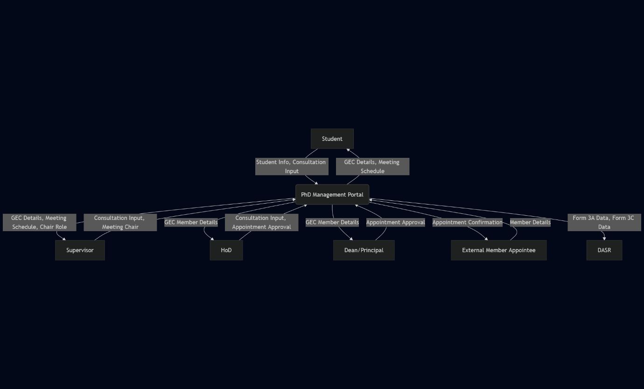
Level 1: GEC Formation & Meeting Process
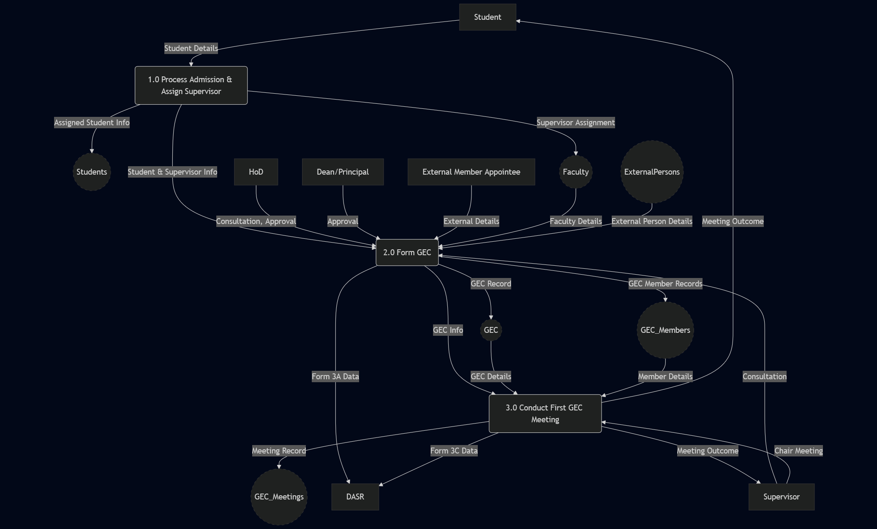

Level 2: Decomposing Process 2.0 (Form GEC)
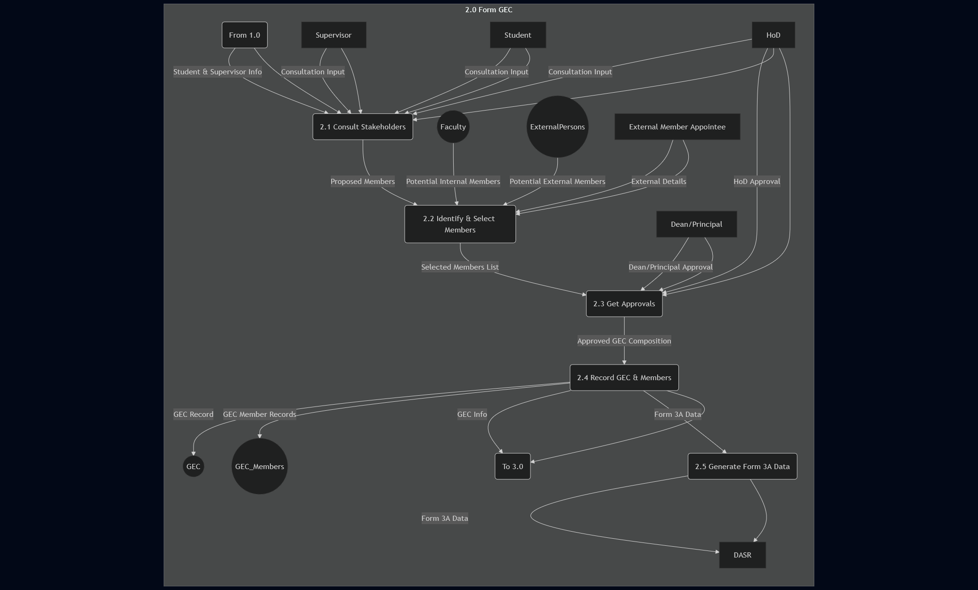
Scenario 2: Qualifying Examination Process (Parts A & B)
- Description: This scenario outlines the steps a student takes after completing coursework to pass the qualifying examination. It involves checking CGPA eligibility, taking the written Part A (Major/Minor papers), receiving results (Form PhD-4), preparing a synopsis, taking the oral Part B (including synopsis defense), and receiving the final qualifying result (Form PhD-5). The process includes potential retakes and interactions with the GEC, HoD, Dean, Subject Specialists, and Examination bodies.
- External Entities: Student, GEC, Supervisor, HoD, Dean, Subject Specialists, Institution Exam Branch, Main Office Exam Directorate, DASR.
- Data Stores: Students, Student_Courses, GEC, QualifyingExams, QualifyingExam_Papers, Theses (for Synopsis).

DFDs for Scenario 2:
Level 0: Context Diagram
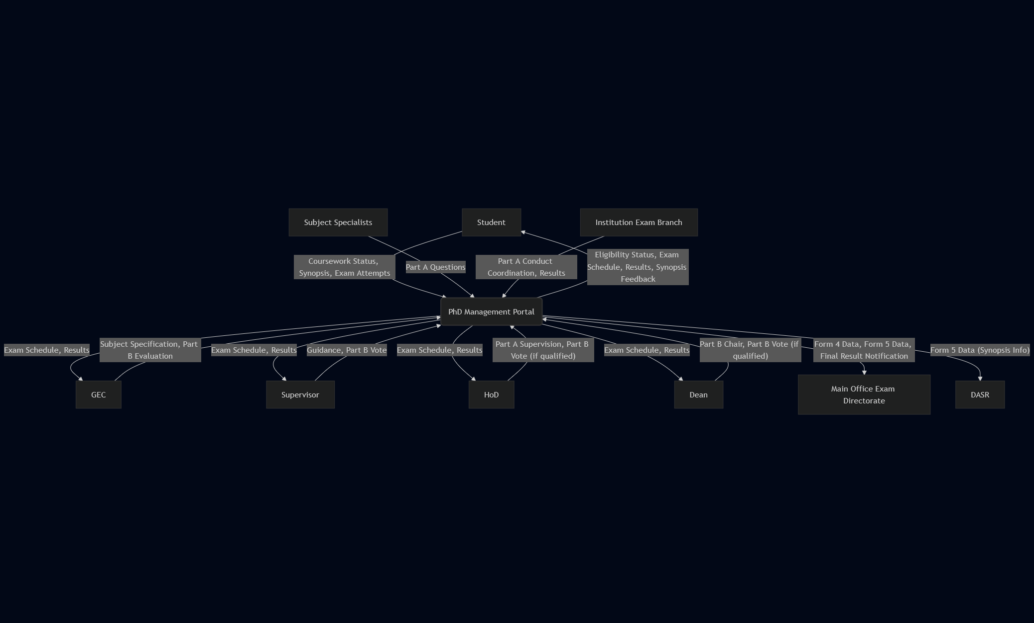
Level 1: Qualifying Exam Workflow
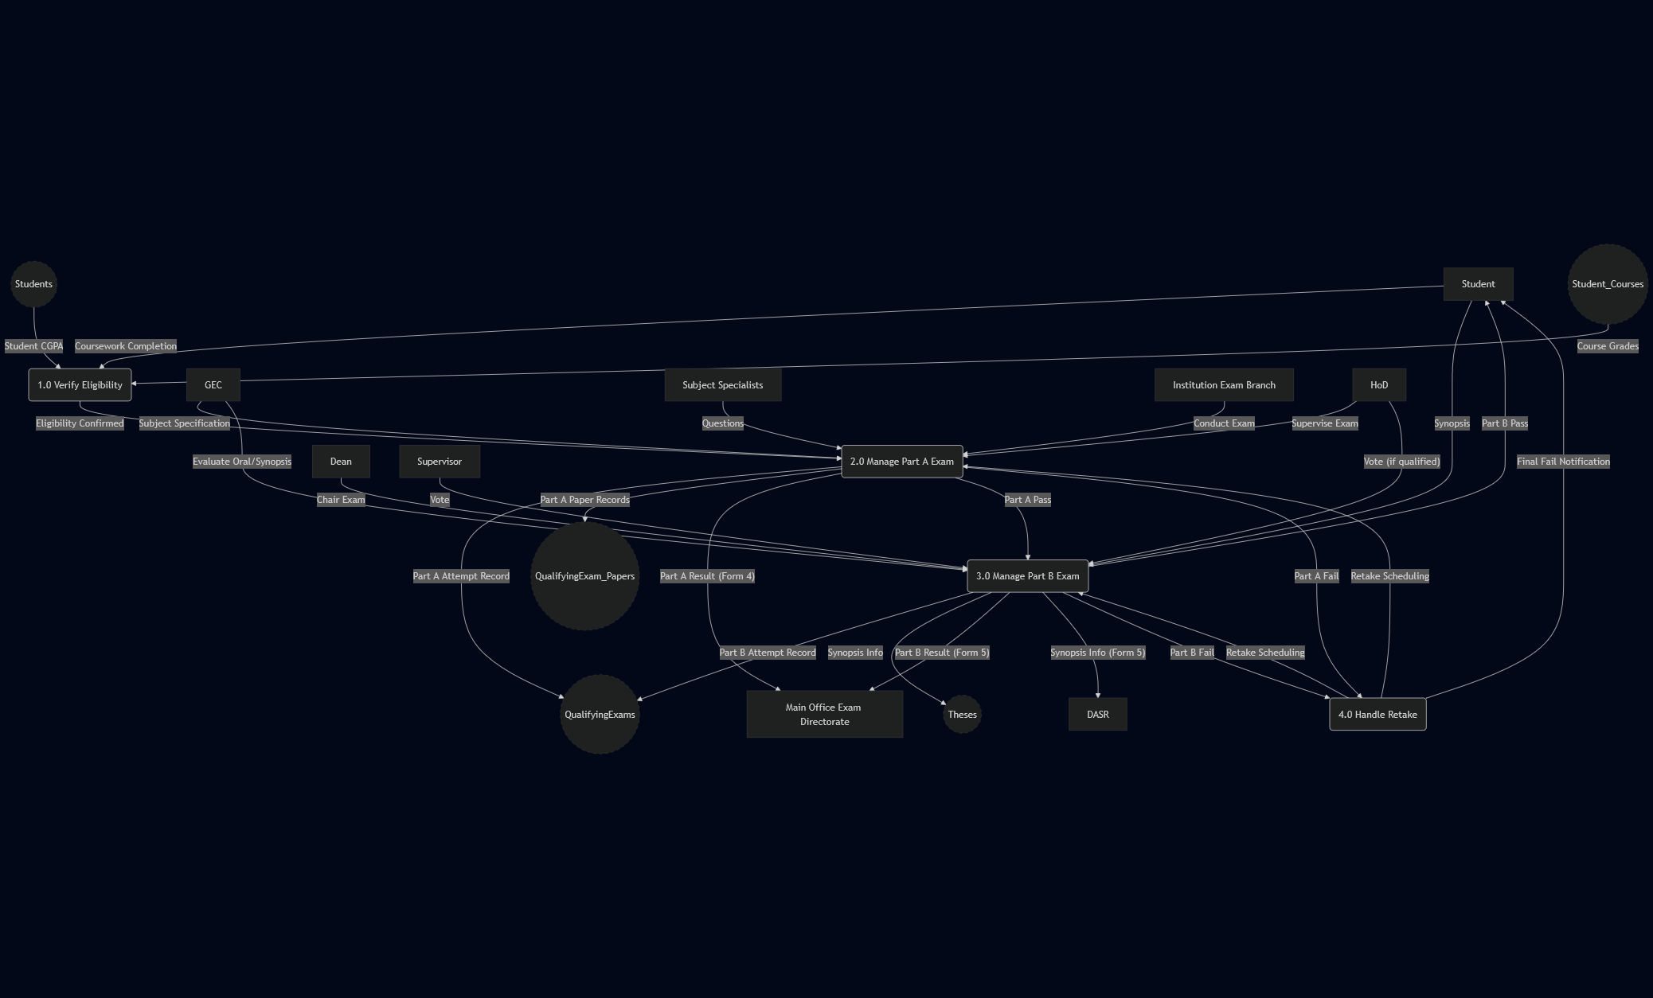

Level 2: Decomposing Process 2.0 (Manage Part A Exam)
